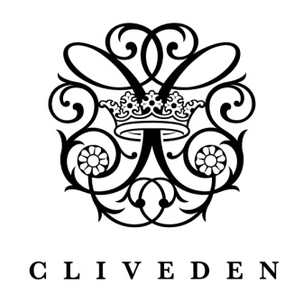

Cliveden House: Pleasure, Power and Politics since 1666
One of the world's finest luxury hotels, this grand stately home is set in the heart of the Berkshire countryside, surrounded by 376 acres of magnificent National Trust managed Grade I listed formal gardens and parkland. Cliveden has wonderful panoramic views over the River Thames and is just 20 minutes drive from Heathrow and 40 minutes from central London and Oxford.
Cliveden’s dramatic history includes philandering Dukes, ‘America’s richest citizen’, house parties for prime ministers and visits by Queen Victoria (though not necessarily in that order). Cliveden House has played host to every British monarch since George I and has been home to three Dukes, an Earl and Frederick Prince of Wales. And let’s not forget the famous (or rather infamous) swim which ultimately led to the downfall of a government (remember the Profumo Affair?) – which is no doubt why Cliveden has the only listed outdoor swimming pool in Britain!
Today the experience is just as memorable but the dining salon has undergone a dramatic interior design transformation. Seduced by this spectacular new dining room that now carries his name, Michelin-starred chef André Garrett has uprooted from Park Lane to put Cliveden firmly back on the gastronomic map.
﻿Impressive surroundings, attentive service and a warm welcome are the hallmarks of Cliveden House making it the perfect venue for business meetings and incentives. It is also ideal for entertaining key clients, showcasing new products or just thanking the team; there are few places more luxurious or more enchanting than Cliveden for a private celebration or gathering.
At Cliveden no two rooms are the same. Each of the 47 bedrooms and the famed two-bedroom Spring Cottage is dramatically decorated in lavish period style. The hotel’s various lounges, private rooms and dedicated meeting spaces offer great flexibility for gatherings from 4 to 120 guests.
Cliveden’s National Trust run gardens and parklands can accommodate bespoke teambuilding days; and golf, off-road driving, horse-riding, fishing, shooting, archery and polo experiences can be arranged nearby. Cliveden Reach is one of the prettiest sections of the Thames and river trips on the hotel’s beautiful flagship Suzy Ann can be enjoyed including champagne cruises down to Bray prior to dinner in one of the village’s famed eateries.
Under the same ownership as Chewton Glen, the award-winning luxury hotel and spa in Hampshire, Cliveden shares an ethos of unparalleled luxury, attention to detail and the finest levels of service.
Cliveden's Andre Garrett Restaurant was named the ‘Restaurant Newcomer of the Year’ in the 2015 edition of the Good Food Guide.

